  Cricket Match outcome prediction  Capstone Project (Final Report) | Abstract  Predict the outcome of a cricket match using machine learning techniques.  Sudarshan John, arien74@gmail.com  Aegis Online BA-BD Course

Contents
Introduction 3
Goal 3
Resources 4
Data 4
Software 4
High-level Approach 5
Data Identification 6
Data Procurement 6
Data Ingestion 6
Sample YAML file extract 6
Explore and Pre-process 10
Data Cleansing 10
Exploration and Pre-Processing 10
Data Normalization 11
Feature Identification – Approach 1 12
Home Team 12
Home Form 12
Away Form 13
Win Percentage 13
Toss 13
Head-to-Head Result (HTH) 13
Team Ranking (NOT used) 14
Feature Identification – Approach 2 15
Model Creation and Evaluation 16
KNN 16
Logistic Regression 17
Model Selection 19
Model Deployment 20
Architecture 21
Challenges Faced 22
Conclusion 23
References 24

Introduction
Outcome of every competitive sporting event involves a certain level of uncertainty. Even on occasions where there is an overwhelming favorite, there have been several instances where the underdog has been victorious. Some of these victories can be attributed to random behavior; however, there exists a large set of scenarios where the result can be tied back to factors that have had a definite bearing on the outcome.
Cricket is one sport where the momentum changes several times in favor of each team playing a match. Having an application that can analyze the factors influencing a match can enable teams to focus their preparation on the key factors that can decide the outcome of a match.
This project attempts to identify factors that can influence the outcome of a cricket match and then build a model that can be used to predict the outcome of a cricket match with reasonable accuracy.
While the task same task can be performed manually, the use of data science techniques enables a repeatable approach that improves accuracy and minimizes errors. The solution can be used as a general approach for predicting outcome of different events given supporting historical data on different aspects that can impact the outcome.

Goal
The goal of this project is to see if it is possible to predict the outcome of cricket matches with good precision. It is to be done by analyzing cricket matches of various types, ODIs and T20s. First, it is crucial to choose features that seem to be significant and to analyze their influence on match outcomes. Second, using supervised machine learning methods, such as KNN, Random Forest, Logistic regression, and others, the model is to produce an output representative of the probable outcome of the match.
Several attempts were made to create a model that would be able to predict the outcome of the games with good precision; however, it has appeared to be very difficult to succeed in this field. Thus, the project is considered to be successful if it predicts the outcome with a precision of 65+%.

Resources

Data
- Data was primarily sourced from the cricsheet website (http://www.cricsheet.org)
- Cricsheet will provide ball-by-ball data for Test Matches, One-day internationals, Twenty20 Internationals, some other international T20s, and all Indian Premier League seasons
- Total 2000+ matches (including Test, T20, and ODI)
- Total dataset size: 300+ MB

Software
- Python, Anaconda, Ubuntu 14.1, Spyder IDE, matplotlib.

High-level Approach
A supervised learning approach was employed to identify the key features that impact match outcomes; once the features have been identified, a training model will be developed and tuned to ensure minimal deviation. The model created will be used to predict match outcomes.
A feedback mechanism will be employed to ensure that new data is used to make the model better.
The overall process is depicted below.

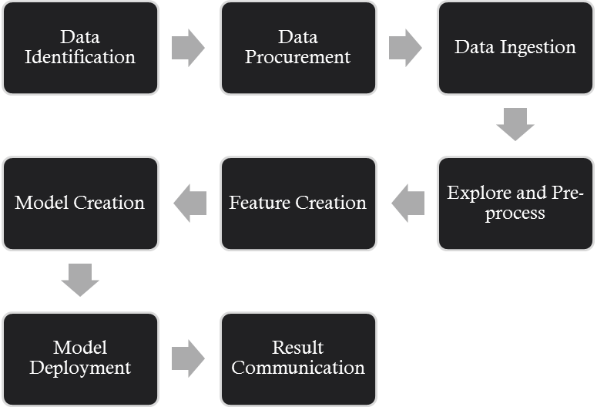

Data Identification
Various sources such as espncricinfo, icc-cricket, and yahoo cricket were considered. Finally, it was decided to go with cricsheet considering easy access to a large set of match data.
Data available included Test, ODI, T20, and Exhibition matches.

Data Procurement
Information for the 2000+ matches was downloaded as a single ZIP file from cricsheet website. Information on each match was available in a YAML format (multi-level dictionary format).

Data Ingestion
Accessing match data involved parsing each YAML file and extracting fields from the file.
The YAML files were parsed using a Python script using the YAML python library that provides parsed information in the form of a dictionary.
All attributes were extracted from each YAML file and saved to a file (csv format).
Some of the key attributes extracted included:
- Competing team names
- Match type (ODI, T20, etc.)
- Number of overs
- Match date
- Umpire names
- Venue and city
- Toss winner
- Toss outcome
- Match winner
Considering the repetitive nature of the process of model creation and time taken to process each YAML file, logic was put in place to ensure that the same file was not processed multiple times. Files that had already been processed were skipped.

Sample YAML file extract

meta:
data_version: 0.6
created: 2013-02-22
revision: 1
info:
city: Southampton
dates:
- 2005-06-13
match_type: T20
outcome:
by:
runs: 100
winner: England
overs: 20
player_of_match:
- KP Pietersen
teams:
- England
- Australia
toss:
decision: bat
winner: England
umpires:
- NJ Llong
- JW Lloyds
venue: The Rose Bowl
innings:
- 1st innings:
team: England
deliveries:
- 0.1:
batsman: ME Trescothick
bowler: B Lee
non_striker: GO Jones
runs:
batsman: 0
extras: 0
total: 0
- 0.2:
batsman: ME Trescothick
bowler: B Lee
non_striker: GO Jones
runs:
batsman: 1
extras: 0
total: 1

Explore and Pre-process

Data Cleansing
During data exploration, it was found that the city detail for many matches was not populated in the dataset. As city details would be needed for determining ‘Home’ and ‘Away’ matches, a python script was used to map from ground names to respective cities

Exploration and Pre-Processing
The first major decision was to focus on ODIs and T20s only; test matches and any other match types (friendly, exhibition) were omitted. There were a number of reasons for this decision. International fixtures in cricket are potentially difficult to predict as all the nations do not play each other regularly enough to provide sufficiently deep training data.
‘Tied’ matches are more complex but the decision was made to exclude them as well as they only occur in around 1% of instances and would therefore need rare event techniques. Moreover, they would never be predicted over a win or loss anyway.
Games where there is ‘no result’ are not suitable for this work and so they were excluded from the data set.
While exploring the data, it was found that there were many teams (such is Namibia etc.) who played very few matches and most matches were restricted to weaker tier-2 teams. Considering a minimum match threshold, a decision was made to restrict the total team count to 10.
The final list of teams taken as input to identify features were:-
- Australia
- Bangladesh
- England
- India
- New Zealand
- Pakistan
- South Africa
- Sri Lanka
- West Indies
- Zimbabwe

Data Normalization
A key step in the data pre-processing stage was normalizing the data across all features. Each feature was modified so that its value was between 0 and 1. Features that were categorical were converted into numbers and normalized.

Feature Identification – Approach 1
It became clear from the initial feature analysis that it the data points available from the base data would not suffice to support the project. There was a need to create additional features using existing features present in the raw data. To be useful in a predictive capacity, a feature had to be informative regarding the outcome in the same way across most matches, rather than just when the dataset was viewed in parts.
Based on existing knowledge about cricket and previously written papers on the subject, it was decided to introduce the following additional features:-

Home Team
This field was added to support the ‘Home-Advantage’ feature. The feature is associated with the team playing the match and whose name appears as the first team name in the raw dataset row. All features are associated in a similar manner with the team whose name appears first in the dataset row.

Home Form
Each team’s home form was assessed to determine whether it had an impact on performance. Home form was calculated by reviewing prior matches to determine win percentages in which a match was played at the teams’ home ground.
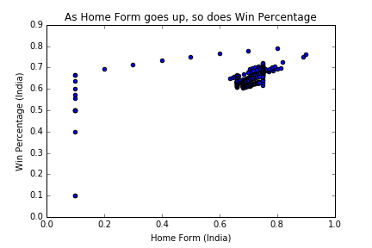

Away Form
Each team’s away form was assessed to determine whether it had an impact on performance. Away form was calculated by reviewing prior matches to determine win percentages in which a match was played at the opponent’s home ground. Away form was also a strong indicator of a team’s relative strength and a strong input into the model training process.
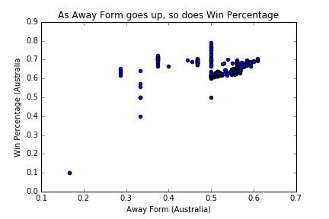

Win Percentage
Historical data was used to calculate a team’s win percentage. It was observed that the stronger teams had higher win percentages and worked as a key input in training the model.

Toss
Impact of the toss on match outcomes was studied. In most cases the toss was an important aspect and was taken into consideration for the model.

Head-to-Head Result (HTH)
Head to Head (HTH) results, the historical performance of one team against the other, was another key aspect that was considered. The HTH seemed like a very logical feature to include since it was a key determinant in the outcome of every match. Teams that had a consistent win record against any other team usually had a bigger chance of repeating the result in future matches.
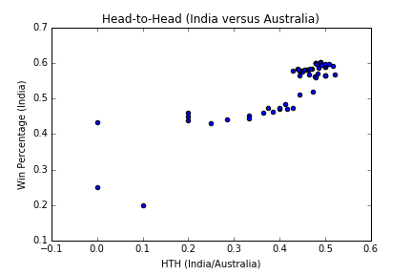

Team Ranking (NOT used)
Team ranking is typically calculated based on a team’s performance relative to its opponents. The International Cricket Council (ICC) publishes team rankings on a periodic basis. Team ranking can be a powerful tool for predicting the outcome of cricket matches. However, for this study, we choose to not use the team ranking feature as the other features contribute to a value that is ultimately used to calculate team ranking. Moreover, using several features as opposed to the team ranking feature enables us greater flexibility in tuning model parameters specific to certain features.

Feature Identification – Approach 2
Subsequent to Round 1 feature identification, it was decided to explore the possibility of using player correlation with match outcomes as opposed to using overall team statistics.
The use of players in the feature identification process provided improved accuracy. Subsequently it was decided to use a player based modeling approach over the team based approach.

Model Creation and Evaluation
The model creation and evaluation process involved iterating through several models and parameter combinations to come up with the best accuracy possible.
Based on papers studied on the topic of cricket / football match outcomes, it was decided to evaluate the performance the KNN, Logistic Regression, and DecisionTree based models.
Each of the models was run through a series of iterations using different parameters to identify the optimal parameters.
The GridSearchCV module from the sklearn python library was primarily used to iterate through different combinations of parameters for each model.
Each model was broken into testing and training sets; the model was trained on the trained set and then evaluated on the testing set. Accuracy scores for each set were measured to compare each of the models.

KNN
The K-nearest neighbor model was tested against the following parameters:-
- K value: Range from 1 to 50
- Weights: Uniform or Distance
The figure below shows the accuracy scores for each of the 50 different K values. The blue is for uniform weights parameter and green for distance based weights parameter.
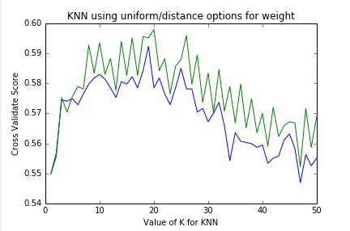
Running GridSearchCV returned the following details:-
- Best score - 0. 597975708502
- Best Params - {'n_neighbors': 20, 'weights': 'distance'}
- Best Estimator - KNeighborsClassifier(algorithm='auto', leaf_size=30, metric='minkowski',
metric_params=None, n_jobs=1, n_neighbors=20, p=2, weights=’distance)

Logistic Regression
The Logistic Regression model was tested against the following parameters:-
- C values: 0.001, 0.01, 0.1, 1, 10, 100, 1000
The figure below shows the accuracy scores for each of the C values.
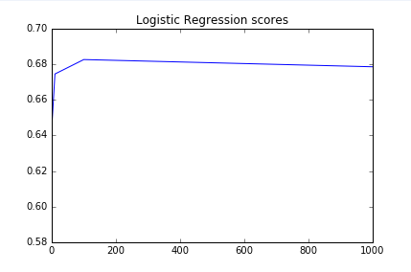
Running GridSearchCV returned the following details:-
- Best score - 0.682591093117
- Best Params - {'C': 100}
- Best Estimator - LogisticRegression(C=100, class_weight=None, dual=False, fit_intercept=True, intercept_scaling=1, max_iter=100, multi_class='ovr', n_jobs=1, penalty='l2', random_state=None, solver='liblinear', tol=0.0001, verbose=0, warm_start=False)

Model Selection
Based on the below results, it was concluded to use the LogisticRegression model as the model to be deployed for solving the cricket match prediction problem.
Model Name | Accuracy
KNN | 0.60
Logistic Regression | 0.68 

Model Deployment
Overall approach for model deployment involves saving the model as a pickle file and copying it over to the machine where model needs to be run.
Once deployed, the model can be used as many times as needed; however, changes to the model would require a re-training and re-deployment of the model using the pickle file.

Architecture
Listed below if the high-level architecture employed for the project.

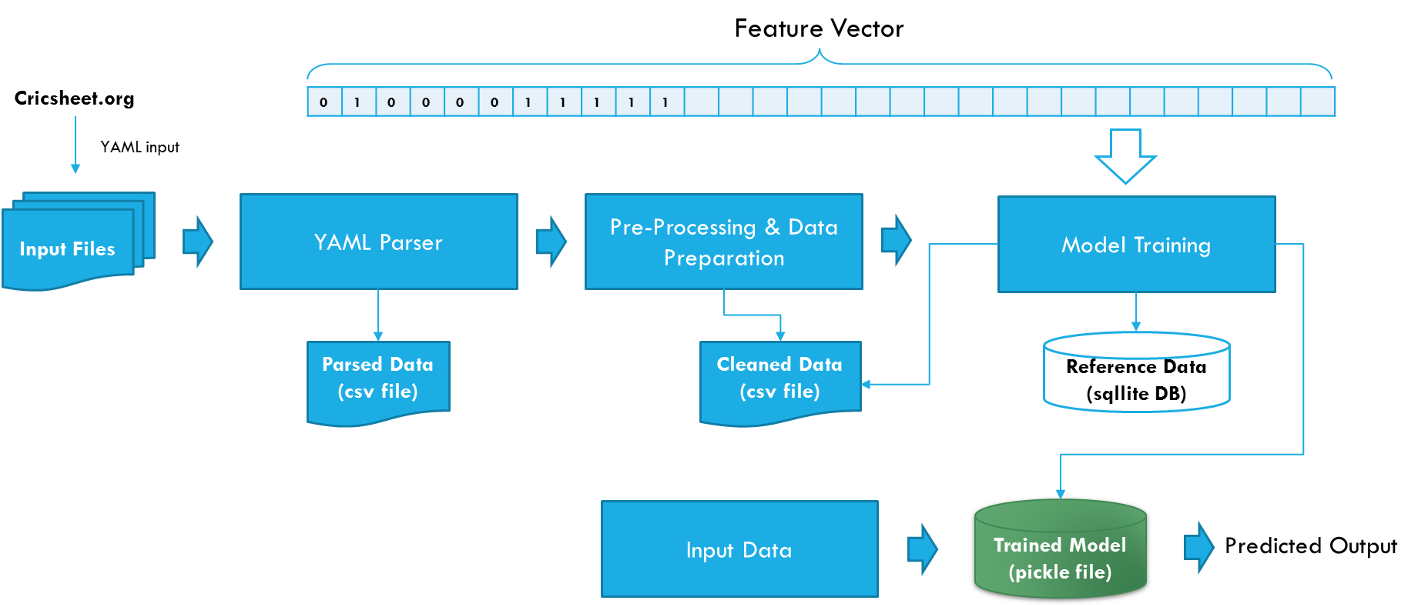

Challenges Faced
Listed below are some of the key challenges faced:-
- Access to detailed cricket match information in a concise and easy to access manner.
- YAML parsing was complicated due to the file format used by the source site.
- Feature identification took several iterations before a fairly accurate model could be trained.
- Maintaining player and team info across different programs without using a database was a challenge.

Conclusion
It is possible to predict the outcome of cricket matches with a reasonable level of accuracy. However, the overall level of accuracy is lower than that observed in many other sports, and undergoes more significant fluctuations on a yearly basis. This suggests that cricket has a relatively high level of instability or randomness within it, which should come as no surprise to those familiar with the game.
Of the various methods tried, the most effective classification method was a simple Logistic Regression model combined with significant data preprocessing and feature selection.
With regards to future work, further avenues could be explored either in the form of new algorithms or in the form of new features. This work has focused entirely on using player presence on a team as features. Use of predominantly categorical features, such as ‘home team’, ‘who won the toss’ and combining these feature types could perhaps yield performance gains. However, algorithm choice would be limited to those capable of dealing with both categorical and numerical features concurrently. In addition, external data such as the weather or social media comments could be mined to provide even more features for further experimentation.

References
- Stylianos Kampakis, William Thomas. Using Machine Learning to Predict the Outcome of English County twenty over Cricket Matches.
- Ben Ulmer, Matthew Fernandez. Predicting Soccer Match Results in the English Premier League.
- Aditya Srinivas Timmaraju, Aditya Palnitkar, Vikesh Khanna. Game On! Predicting English Premier League Match Outcomes.

